**Business Request 1: Monthly Circulation Drop Check**

**Find top 3 months where any city had the sharpest MoM decline in net_circulation**

WITH city_monthly AS (

SELECT

c.city AS city_name,

ps.month AS month_date, -- actual DATE column

DATE_FORMAT(ps.month, '%Y-%m') AS month_yr, -- YYYY-MM format

MONTHNAME(ps.month) AS month_name, -- Full month name (e.g., January)

SUM(ps.net_circulation) AS net_circulation

FROM fact_print_sales ps

JOIN dim_city c ON ps.city_id = c.city_id

GROUP BY c.city, ps.month

),

city_mom AS (

SELECT

city_name,

month_date,

month_yr,

month_name,

net_circulation,

LAG(net_circulation) OVER (PARTITION BY city_name ORDER BY month_date) AS prev_net

FROM city_monthly

)

SELECT

city_name,

month_yr,

month_name,

net_circulation,

(net_circulation - prev_net) AS mom_change

FROM city_mom

WHERE prev_net IS NOT NULL

ORDER BY mom_change ASC

LIMIT 3;

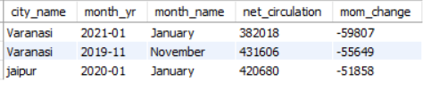

**Business Request – 2: Yearly Revenue Concentration by Category Identify ad categories that contributed > 50% of total yearly ad revenue.**

WITH yearly_revenue AS (

SELECT

YEAR(ar.quarter_start_date) AS year,

dac.category_group AS category_name,

SUM(ar.Ad_Revenue_INR) AS category_revenue

FROM fact_ad_revenue ar

JOIN dim_ad_category dac ON ar.ad_category = dac.ad_category_id

GROUP BY YEAR(ar.quarter_start_date), dac.category_group

),

year_totals AS (

SELECT year, SUM(category_revenue) AS total_revenue_year

FROM yearly_revenue

GROUP BY year

)

SELECT

yr.year,

yr.category_name,

yr.category_revenue,

yt.total_revenue_year,

ROUND(yr.category_revenue / yt.total_revenue_year * 100, 2) AS pct_of_year_total

FROM yearly_revenue yr

JOIN year_totals yt ON yr.year = yt.year

ORDER BY yr.year, pct_of_year_total DESC; 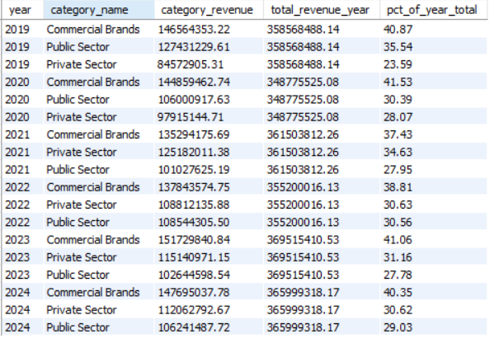

WITH yearly_revenue AS (

SELECT

YEAR(ar.quarter_start_date) AS year,

dac.category_group AS category_name,

SUM(ar.Ad_Revenue_INR) AS category_revenue

FROM fact_ad_revenue ar

JOIN dim_ad_category dac ON ar.ad_category = dac.ad_category_id

GROUP BY YEAR(ar.quarter_start_date), dac.category_group

),

year_totals AS (

SELECT year, SUM(category_revenue) AS total_revenue_year

FROM yearly_revenue

GROUP BY year

),

ranked AS (

SELECT

yr.year,

yr.category_name,

yr.category_revenue,

yt.total_revenue_year,

ROUND(yr.category_revenue / yt.total_revenue_year * 100, 2) AS pct_of_year_total,

RANK() OVER (PARTITION BY yr.year ORDER BY yr.category_revenue DESC) AS rnk

FROM yearly_revenue yr

JOIN year_totals yt ON yr.year = yt.year

)

SELECT *

FROM ranked

WHERE rnk = 1

ORDER BY year; 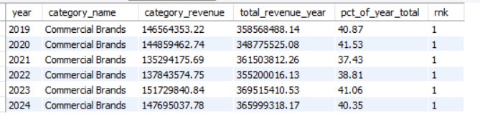**Business Request – 3: 2024 Print Efficiency Leaderboard For 2024, rank cities by print efficiency = net_circulation / copies_printed. Return top 5.** WITH city_2024 AS (

SELECT

c.city AS city_name,

SUM(ps.`Copies Sold` + ps.copies_returned) AS copies_printed_2024,

SUM(ps.Net_Circulation) AS net_circulation_2024

FROM fact_print_sales ps

JOIN dim_city c ON ps.City_ID = c.city_id

WHERE YEAR(ps.Month) = 2024

GROUP BY c.city

)

SELECT

city_name,

copies_printed_2024,

net_circulation_2024,

ROUND(net_circulation_2024 / NULLIF(copies_printed_2024, 0), 3) AS efficiency_ratio,

RANK() OVER (ORDER BY net_circulation_2024 / NULLIF(copies_printed_2024, 0) DESC) AS efficiency_rank_2024

FROM city_2024

ORDER BY efficiency_rank_2024

LIMIT 5;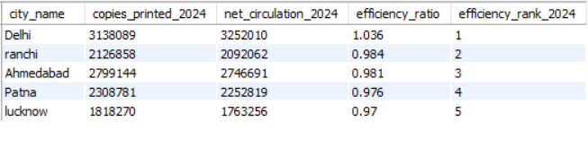

Business Request – 4 : Internet Readiness Growth (2021)

-- For each city, compute the change in internet penetration from Q1-2021 to Q4-2021

-- and identify the city with the highest improvement.

WITH readiness_2021 AS (

SELECT

city_id,

MAX(CASE WHEN quarter = '2021-Q1' THEN internet_penetration END) AS internet_rate_q1_2021,

MAX(CASE WHEN quarter = '2021-Q4' THEN internet_penetration END) AS internet_rate_q4_2021

FROM fact_city_readiness

WHERE quarter LIKE '2021-%'

GROUP BY city_id

),

delta_2021 AS (

SELECT

city_id,

internet_rate_q1_2021,

internet_rate_q4_2021,

round((internet_rate_q4_2021 - internet_rate_q1_2021),2) AS delta_internet_rate

FROM readiness_2021

)

SELECT

dim.city AS city_name,

d.internet_rate_q1_2021,

d.internet_rate_q4_2021,

d.delta_internet_rate

FROM delta_2021 d

JOIN dim_city dim ON d.city_id = dim.city_id

ORDER BY d.delta_internet_rate DESC; 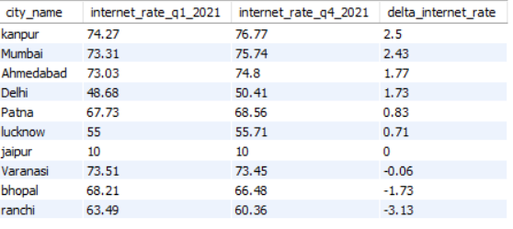

**Business Request – 5: Consistent Multi-Year Decline (2019→2024) Find cities where both net_circulation and ad_revenue decreased every year from 2019 through 2024 (strictly decreasing sequences).**

WITH yearly_print AS (

SELECT

City_ID,

YEAR(Month) AS year,

SUM(Net_Circulation) AS yearly_net_circulation

FROM fact_print_sales

WHERE YEAR(Month) BETWEEN 2019 AND 2024

GROUP BY City_ID, YEAR(Month)

),

yearly_ad AS (

SELECT

fps.City_ID,

YEAR(far.quarter_start_date) AS year,

SUM(far.Ad_Revenue_INR) AS yearly_ad_revenue

FROM fact_ad_revenue far

JOIN fact_print_sales fps ON far.edition_id = fps.edition_ID

WHERE YEAR(far.quarter_start_date) BETWEEN 2019 AND 2024

GROUP BY fps.City_ID, YEAR(far.quarter_start_date)

),

combined AS (

SELECT

p.City_ID,

p.year,

yearly_net_circulation,

yearly_ad_revenue,

LAG(yearly_net_circulation) OVER (PARTITION BY p.City_ID ORDER BY p.year) AS prev_circulation,

LAG(yearly_ad_revenue) OVER (PARTITION BY p.City_ID ORDER BY p.year) AS prev_ad

FROM yearly_print p

JOIN yearly_ad a ON p.City_ID = a.City_ID AND p.year = a.year

)

SELECT

dim.city AS city_name,

c.year,

c.yearly_net_circulation,

c.yearly_ad_revenue,

CASE

WHEN prev_circulation IS NULL THEN 'Yes'

WHEN c.yearly_net_circulation < prev_circulation THEN 'Yes'

ELSE 'No'

END AS is_declining_print,

CASE

WHEN prev_ad IS NULL THEN 'Yes'

WHEN c.yearly_ad_revenue < prev_ad THEN 'Yes'

ELSE 'No'

END AS is_declining_ad_revenue,

CASE

WHEN (prev_circulation IS NULL OR c.yearly_net_circulation < prev_circulation)

AND (prev_ad IS NULL OR c.yearly_ad_revenue < prev_ad)

THEN 'Yes'

ELSE 'No'

END AS is_declining_both

FROM combined c

JOIN dim_city dim ON c.City_ID = dim.city_id

ORDER BY dim.city, c.year;

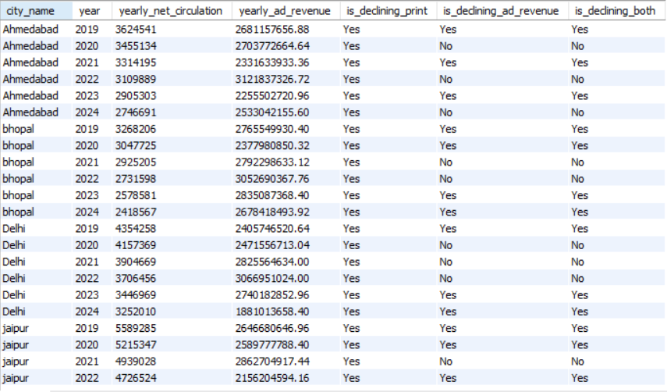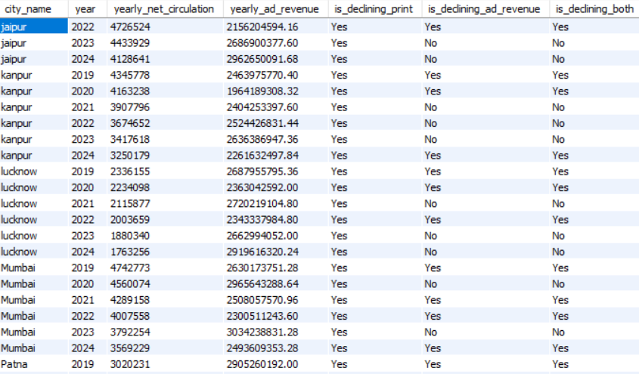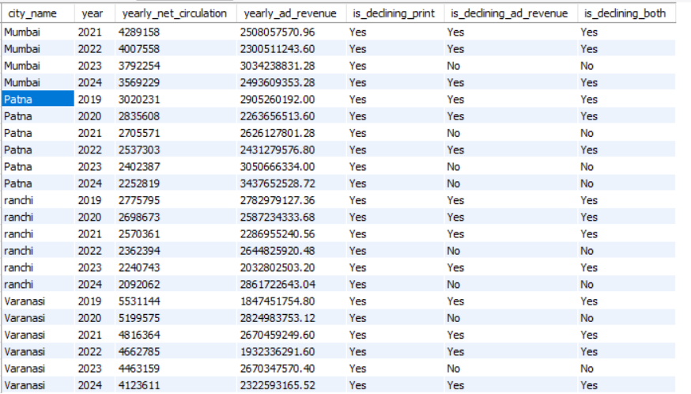

**Business Request – 6 : 2021 Readiness vs Pilot Engagement Outlier In 2021, identify the city with the highest digital readiness score but among the bottom 3 in digital pilot engagement.**

WITH readiness_2021 AS (

SELECT

city_id,

ROUND((AVG(smartphone_penetration) + AVG(internet_penetration) + AVG(literacy_rate)) / 3, 2) AS readiness_score_2021

FROM fact_city_readiness

WHERE quarter LIKE '%2021%'

GROUP BY city_id

),

engagement_2021 AS (

SELECT

city_id,

SUM(users_reached) AS engagement_metric_2021

FROM fact_digital_pilot

WHERE launch_month LIKE '2021%'

GROUP BY city_id

),

ranked AS (

SELECT

r.city_id,

r.readiness_score_2021,

e.engagement_metric_2021,

RANK() OVER (ORDER BY r.readiness_score_2021 DESC) AS readiness_rank_desc,

RANK() OVER (ORDER BY e.engagement_metric_2021 ASC) AS engagement_rank_asc

FROM readiness_2021 r

JOIN engagement_2021 e ON r.city_id = e.city_id

)

SELECT

dim.city AS city_name,

ranked.readiness_score_2021,

ranked.engagement_metric_2021,

ranked.readiness_rank_desc,

ranked.engagement_rank_asc,

CASE

WHEN ranked.readiness_rank_desc = 1 AND ranked.engagement_rank_asc <= 3 THEN 'Yes'

ELSE 'No'

END AS is_outlier

FROM ranked

JOIN dim_city dim ON ranked.city_id = dim.city_id;